**Gold Starburst Framed Decorative Mirror**

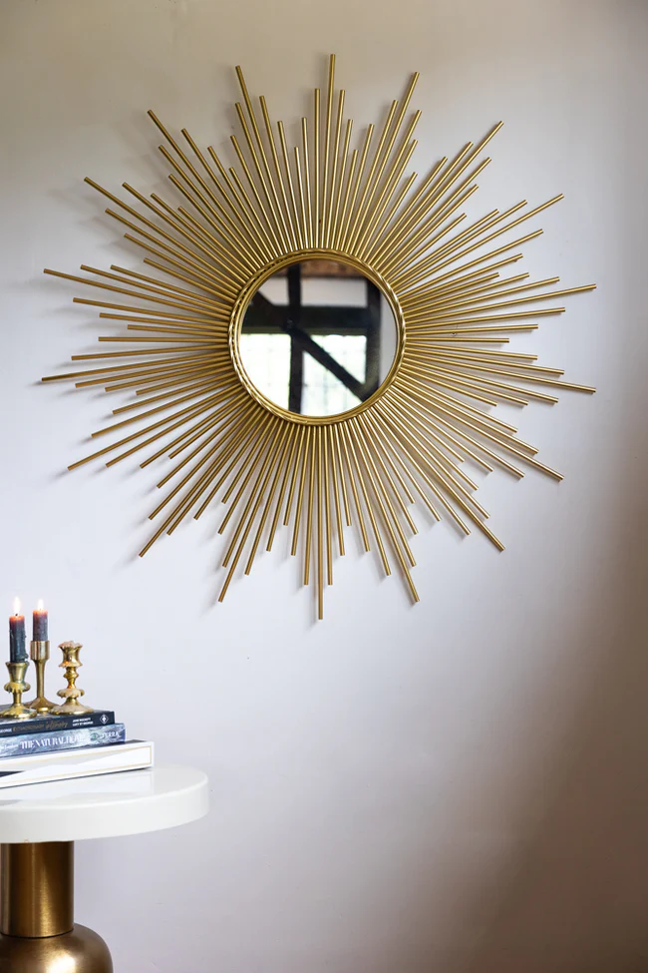The Gold Starburst Framed Decorative Mirror is a captivating statement piece that radiates sophistication and modern flair. Its unique starburst design features bold, elongated rays extending outward from the mirror’s center, creating a dynamic and eye-catching effect. The rich gold finish adds a touch of luxury, while the geometric shape makes it perfect for contemporary, mid-century, or eclectic interiors. This mirror not only serves as a functional reflective surface but also as a striking piece of art, drawing attention and adding a sense of depth to any room. Whether in a living room, hallway, or entryway, it effortlessly enhances your space with timeless elegance and style.